Initial Questions:
1a) Independent redox constraints on our test system indicate QFM+0.4 at 1200°C and 420 bars. In your
model, what log(fO2) would you calculate in bars? Make sure to specify which equation you are using to
calculate fO2 from a buffer position (or provide a tool/spreadsheet if you do not have it hard coded).

Model 2A
Step at 46µm
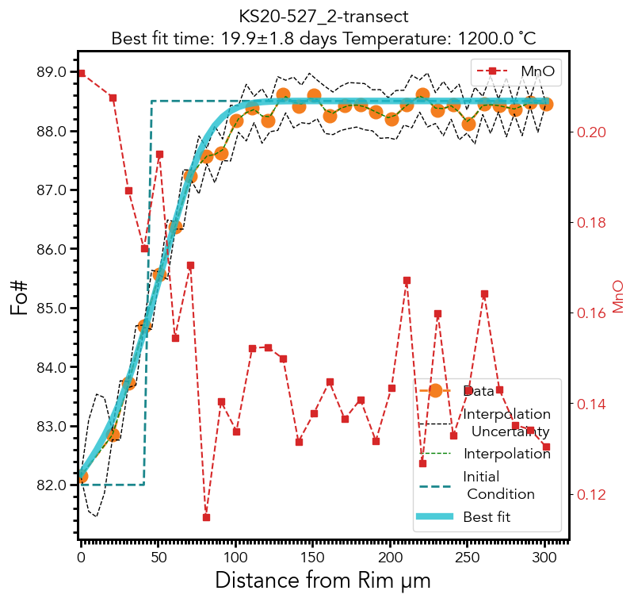

Step at 41µm
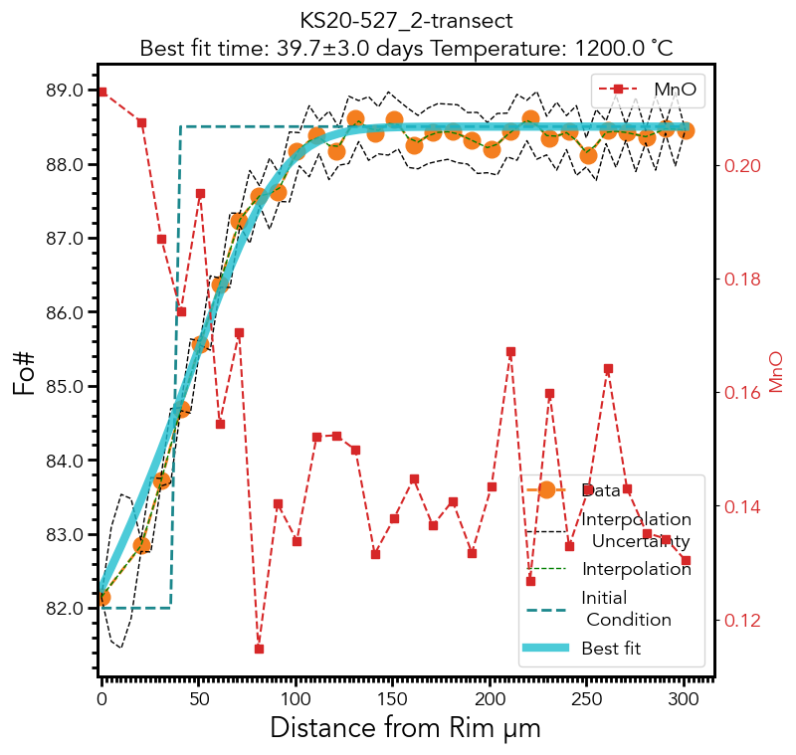
Step at 51µm

